Welcoming Prayer

Welcoming Prayer: Centering Prayer in the Midst of Doing Real Life.
Welcoming Prayer is simply Centering Prayer in the midst of a difficult moment, in the midst of doing real life. With Welcoming Prayer, you and I can learn to utilize the same tools found in Centering Prayer (relaxed attentiveness, quietness, and surrender) and apply them to a present moment of frustration, just when our false self is dangerously close to acting out of its woundedness.

Look at the diagram below, The False Self in Action (thanks to Dr. Cynthia Bourgeault), and notice the patterns of our faulty behavior. Let’s start with the triangle: Emotional Programs for Happiness (1), just under the surface of our consciousness. If you’re familiar with the Enneagram personality awareness test, you know that each one of us has been conditioned from childhood to use one of three approaches to finding happiness. The first is Power/Control where we manage our lives by attempting to control the world around us. The second is Esteem/Affection where we hope to find happiness by earning people’s approval. The third is Security/Survival where we remove perceived threats in life by reducing interaction with people and situations that we fear.
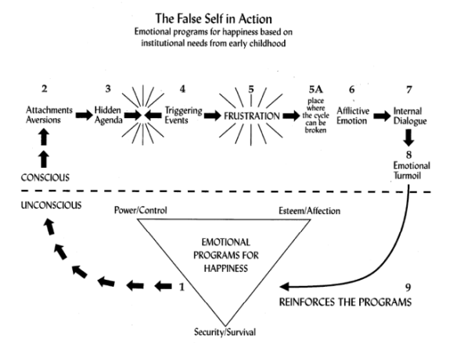

Over time, as bad things happen to us in life, our false self constructs an elaborate security system to substantiate in the real world what is going on in our unconscious mind just below the surface of our lives. The false self designs and activates a unique set of attachments/aversions (2) and hidden agendas (3) which are custom-designed to guard our hearts from any further damage, pain or woundedness. But sure enough, despite all of our defenses, “life” happens with triggering events (4), explosive moments with people or situations that “flip our trigger” or “push the wrong button,” placing us on a collision course with high level frustration (5).
Sadly, we all know what these unresolved moments of frustration generally do to us. If left unchecked, we go full-speed ahead with our thoughts, entertaining afflictive, passionate emotions (6), combining them with internal dialogue (7) (example: “I told you this would happen, etc. etc.”), followed by emotional turmoil (8) so destructive, we vow to never let this kind of stuff ever happen again! This horrific event then gets stored back into our unconsciousness (below the surface), reinforcing our Emotional Program For Happiness (1), and the whole ugly cycle starts up once again.
Get the picture?
But, here’s the good news! Welcoming Prayer is our God-given opportunity to stop right in the midst of a difficult situation, when you or I are tempted to go to the worst places of our false self, and intentionally insert a break in the cycle, a God-event that can truly interrupt the ugly patterns our false self has depended upon for years!
Welcoming Prayer (see 5a on the diagram) is taking advantage of that very slim moment of time, a unique slice of opportunity before our thoughts become a passionate emotion. Our goal here is to dismantle Emotional Programs for Happiness and heal wounds of a lifetime by addressing them where they are stored — in our body.
So now, let us give you the three steps of Welcoming Prayer. We suggest you go slowly and allow each of these steps to do its full work.
Focus & sink in on the reality of the moment. To focus on the upset means to feel it as a sensation in your body. Gently become aware of your body and your interior state. Sink into the reality of your feelings. Feel the pain. Feel the knot in your stomach. Feel the ache in your head or the lump in your throat. Pay close attention to what it feels like inside you. Don’t analyze or repress the unpleasant feelings, but allow God to help you become physically aware of the way your body is responding to the frustration you are currently experiencing.

Welcome the feeling/emotion that’s associated with the moment. The good/bad/ugly – welcome the pain/feeling/emotion by name. Name it. Own it. Hold it with inner hospitality. This approach will feel strange to you at first. Society says to push it away or stuff it down. But don’t. And as you welcome it, remember that welcoming is vastly different than condoning or excusing the sin/sickness that surrounds the situation. Welcoming doesn’t mean rolling over & playing dead. It means coming to a place of holy indifference, where Jesus is at the center of your frustrations and has all of this in His care. Embracing the feeling/emotion in the presence of Jesus breaks its power in you.
Note: Don’t go too quickly through these first two steps. Return to them as much as it is necessary for you to gain a fuller awareness of things that are going on inside you. You might ask yourself, “Which Emotional Program for Happiness is at the core of my frustration. Is it my need to control? A hunger for approval? A desire for security and safety?

Let it all go. Much like a fisherman knows “catch & release,” it’s now time for you to “release” and let go of the feelings/emotions you have just recognized. Invite Jesus to join you, asking for the empowering presence of the Holy Spirit in letting go of all you’ve recognized about yourself and this current frustration. End your time by offering yourself back to God, asking Him to lead and guide you going forward in His peace, even as the circumstances surrounding your frustrations may still be alive.

Here’s a sample Welcoming Prayer from Father Thomas Keating…
