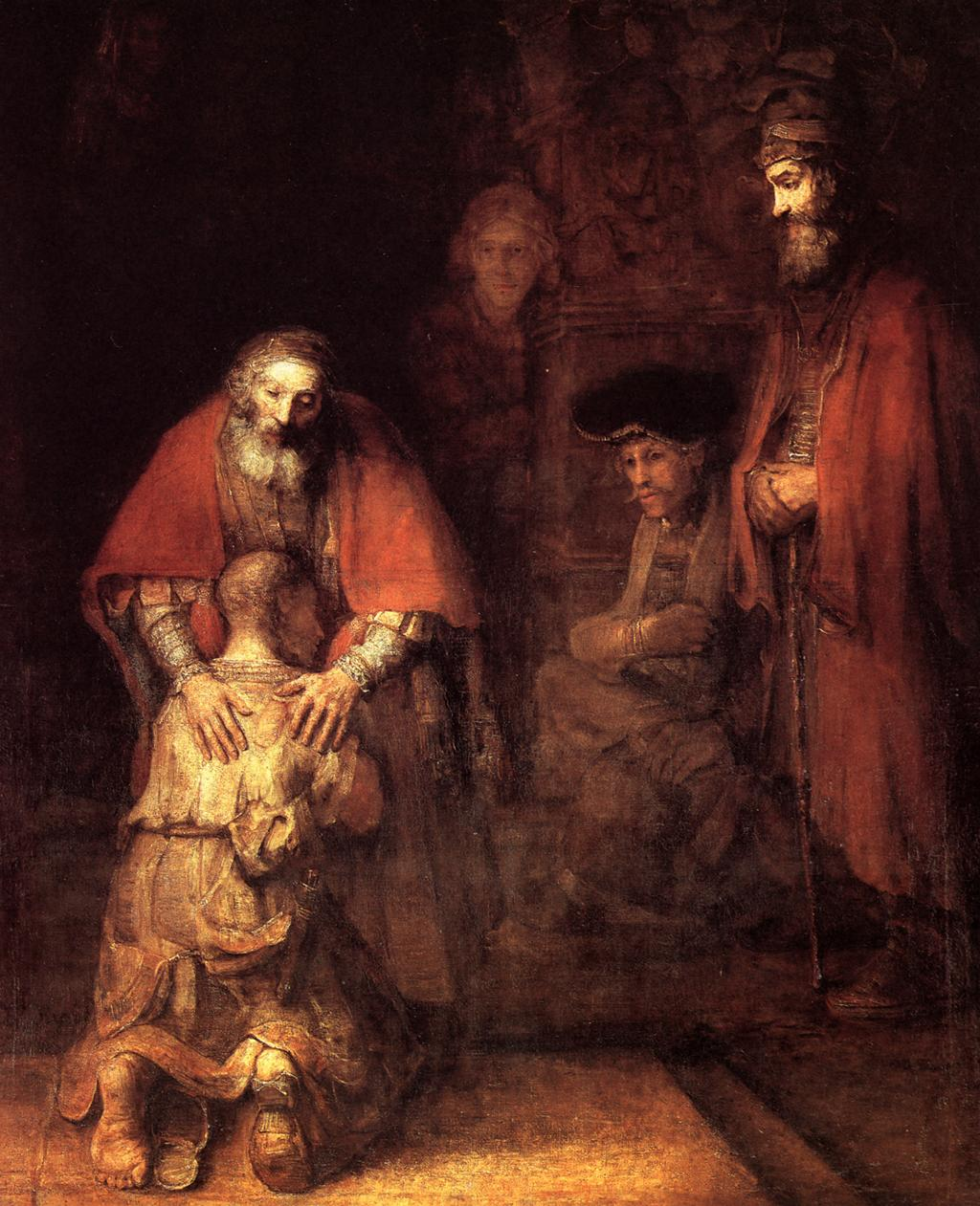

Luke 15:11-32 The Voice
¹¹ Once there was this man who had two sons. ¹² One day the younger son came to his father and said, “Father, eventually I’m going to inherit my share of your estate. Rather than waiting until you die, I want you to give me my share now.” And so the father liquidated assets and divided them. ¹³ A few days passed and this younger son gathered all his wealth and set off on a journey to a distant land. Once there he wasted everything he owned on wild living. ¹⁴ He was broke, a terrible famine struck that land, and he felt desperately hungry and in need. ¹⁵ He got a job with one of the locals, who sent him into the fields to feed the pigs. ¹⁶ The young man felt so miserably hungry that he wished he could eat the slop the pigs were eating. Nobody gave him anything.
¹⁷ So he had this moment of self-reflection: “What am I doing here? Back home, my father’s hired servants have plenty of food. Why am I here starving to death? ¹⁸ I’ll get up and return to my father, and I’ll say, ‘Father, I have done wrong—wrong against God and against you. ¹⁹ I have forfeited any right to be treated like your son, but I’m wondering if you’d treat me as one of your hired servants?’” ²⁰ So he got up and returned to his father. The father looked off in the distance and saw the young man returning. He felt compassion for his son and ran out to him, enfolded him in an embrace, and kissed him.
²¹ The son said, “Father, I have done a terrible wrong in God’s sight and in your sight too. I have forfeited any right to be treated as your son.”
²² But the father turned to his servants and said, “Quick! Bring the best robe we have and put it on him. Put a ring on his finger and shoes on his feet. ²³ Go get the fattest calf and butcher it. Let’s have a feast and celebrate ²⁴ because my son was dead and is alive again. He was lost and has been found.” So they had this huge party.
²⁵ Now the man’s older son was still out in the fields working. He came home at the end of the day and heard music and dancing. ²⁶ He called one of the servants and asked what was going on. ²⁷ The servant said, “Your brother has returned, and your father has butchered the fattest calf to celebrate his safe return.”
²⁸ The older brother got really angry and refused to come inside, so his father came out and pleaded with him to join the celebration. ²⁹ But he argued back, “Listen, all these years I’ve worked hard for you. I’ve never disobeyed one of your orders. But how many times have you even given me a little goat to roast for a party with my friends? Not once! This is not fair! ³⁰ So this son of yours comes, this wasteful delinquent who has spent your hard-earned wealth on loose women, and what do you do? You butcher the fattest calf from our herd!”
³¹ The father replied, “My son, you are always with me, and all I have is yours. ³² Isn’t it right to join in the celebration and be happy? This is your brother we’re talking about. He was dead and is alive again; he was lost and is found again!”

VISIO DIVINA: Luke 15: 11-32 (Jesus’ story of the returning prodigal)

Step One: Breath prayer/centering prayer: slowing down in order to make room for God. Ask Jesus to join with you as you slow down.

Step Two: Gaze and ponder on Rembrandt’s The Return of the Prodigal Son. Slowly read Luke 15: 11-32. Pick one of the five faces that seem to stand out (or shimmer) for you. Ponder on the inner thoughts/feelings of that one person you’ve chosen.

Step Three: Imagine a conversation or a dialogue (a colloquy) you might have with that person. Write out the conversation, if that is helpful for you. Consider the emotions/feelings of that person. What are your emotions/feelings as you reflect on this part of the story?

Step Four: Share your conversation/thoughts/feelings with your spiritual director, or in a spiritual direction group setting.

A Teaching Moment:
^{GENESIS 1: 26-27} Then God said, “Let us make mankind in our image, in our likeness, so that they may rule over the fish in the sea and the birds in the sky, over the livestock and all the wild animals, and over all the creatures that move along the ground.” So God created mankind in His own image, in the image of God He created them; male and female He created them.
Consider this: Each of the five faces depicted in Rembrandt’s Prodigal painting is a face “created in the image of God.” Yet, because of the freedoms God gives each of His children, the “likeness of God” (His nature, His traits, His character) may or may not find complete fulfillment in our lives.

“In creating us God gives us the image, so we are born with it. The likeness is something greater than the image, and God gives us the responsibility of acquiring it.” Basil

Freedom and responsibility are gifts from God that constitute central facets of the divine image. God, who loves us, has given us freedom so that unlike robots or puppets we can love Him in return. We choose what we do, what habits we cultivate, which cultural influences and role models we follow, and what we will become in the future. Like actors capable of playing different roles in the same play, we can take on the likeness of God, but we can choose the likeness of a savage beast instead, or even the likeness of a devil. Yet we are capable of choosing and doing good and have a responsibility to do so. We remain free, although our freedom is limited. Yet we can take tiny positive steps that enable further tiny positive steps. Over time our bad habits and addictions can be overcome by God’s grace, wise practical training, and our own sustained efforts. We are invited to work with God to co-create our future identity in a way that is more and more Christ-like. When we follow this calling we also acquire more and more inner freedom. As we grow spiritually, we become aware of our choices and opt for goodness instead of being driven by cultural influences, bad habits, or misguided impulses. The greatest freedom is loving God and neighbor spontaneously by discerning God’s will and choosing it in every moment. (from Conclusion, Harrison, Nonna Verna Harrison God's Many-Splendored Image: Theological Anthropology for Christian Formation)

