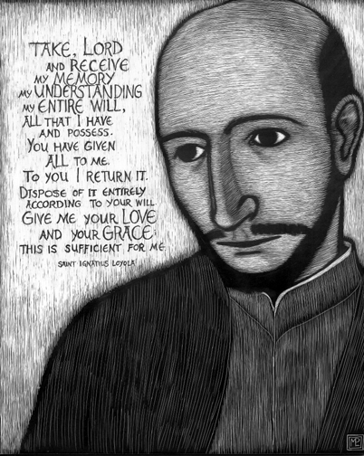

The Examen: A Reorienting Rhythm for A Distracted Age

The Examen is a prayer exercise used at least one time per day that is integral to the Spiritual Exercises created by Ignatius of Loyola – the founder of the Jesuits (the current Pope Francis is a Jesuit). For centuries, the Examen has become a prayerful reflection of self-awareness in order to detect God’s presence and discern His direction for us. There are many different formats used in the Examen. Here is a simple way to begin…
After some time of silence & solitude, remain still and bring three questions to mind. Allow yourself to relax and ask Jesus to help you respond as honestly and simply as you can…
- Acknowledge at least one person, place or thing that you are truly thankful for today.
- Review at least one situation that has happened today that has drawn you closer to Jesus.
- Review at least one situation that has happened today that has taken you away from Jesus.
Don’t be-labor these three questions. Give yourself the freedom and grace to answer these questions freely and openly.
Now, once you’ve arrived at your answers, the Examen adds these two additional suggestions…
- As you reflect upon your feelings that are stirred within as you answered the three questions above, take a moment and bring these feelings to Jesus of Nazareth, inviting Him to bring His good into them. Sit quietly in that good you might feel.
- Now, take a moment and tell Jesus how you’d like to respond to these feelings going forward. Invite Him to be with you as you go. Invite Him to give you the good you need for the remainder of this day.

